PEEHIP Refund Process for Terminated Employees

- The recommended refund process for terminated employees via NextGen is using the Offline Deduction Refund payroll process.
- All refund employees must have a valid 2019 GL record totaling 100% on the job record being used for the refund.
- The job record(s) being used for the refund must not have a pay period code of No-Pay.
- Identify the last check/statement number the employees had PEEHIP withheld on. This number will be needed when entering the deduction refund. This should be completed ahead of processing Offline checks for all terminated employees.
- PEEHIP will provide the most recent address on file for all terminated employees. These addresses may need to be updated in NextGen.
- If you decide to process the refunds for separate batches, you will need to set up a new Offline Deduction Refund payroll Run ID for each batch.
- When setting up the Offline Deduction Refund Run ID, select the Include Terminated option on Tab #2. This will allow you to leave employee terminated while still being able to process the deduction refunds through the Offline payroll Run.
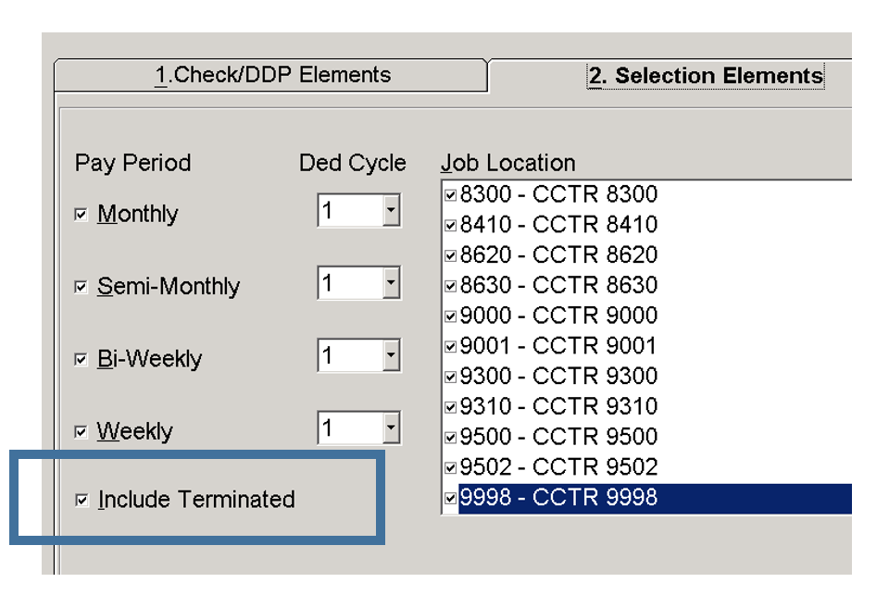

- In the Record Off-Line PR Check transaction, follow the normal Offline Deduction Refund steps.
  - Select the payroll run ID.
  - Enter the employee number.
  - Select the payroll bank code.
  - Enter the original check/statement number. The selected check must have the PEEHIP deduction on it so it can be referenced for the refund. This information should have been gathered in Step #4 above.
  - Select the PEEHIP deduction from the (Ded#) drop-down field.
  - Select the appropriate job number from the (JN) field.
  - Press Tab to load the original withholding amount from the previous check’s selected job number. This amount cannot exceed the original deduction amount at this moment. This amount will be changed to reflect the total PEEHIP refund in steps (J & P) below.
  - Click Add to add the record to the list view.
  - After adding the record to the list view, click the Update button on the toolbar.
  - Once updated, click on the PEEHIP deduction line and change the negative amount to reflect the PEEHIP refund (Premium Only Amount). Make sure the refund amount remains a negative number.
  - Add the modified record back to the list view.
  - If the original check included multiple job records and you wish to distribute the refund over all jobs, repeat steps E, F, G, H, I, J, and K for each job record. If distributing over multiple jobs, the total refund amount for all jobs should equal the total PEEHIP refund (Premium Only Amount). Make sure the refund amounts remain negative numbers.
  - Once all of the line(s) have been added back to the list view, click the Calculate option on the toolbar to calculate taxable wages and withholdings.
  - For Offline deduction refund checks, Federal and State tax withholdings are calculated based on the current tax tables and employee’s tax settings. Please check the calculated withholdings and if you feel they are not reasonable, the amounts can be changed.
  - If necessary, to change tax withholding amounts, click on the tax line item, change the withholding amount in the entry field above the list view and click Add to add it back to the list view. Do not change taxable wages.
  - To add in the PEEHIP Interest refund amount so that it is not subject to taxes, click on the PEEHIP deduction line item and change the PEEHIP refund amount to be the total of both the Premium and Interest refunds. Make sure the refund amount(s) remain negative numbers.
  - Click Add to add the record to the list view.
  - Click the Update option on the toolbar to save the record. (Do not adjust the tax deduction line items and do not click calculate again.)
  - After clicking Update, the next employee is ready to be entered.
- Repeat the Offline check entry process for each employee being refunded in the payroll Run ID.
- After entering all employees, complete the remainder of the Offline check process from the Payroll Register through the Check Update.
- Either before or after processing the Offline Deduction Refunds, the refund deposit and journal entry will need to be recorded.
  - Deposit the refund check(s) from Peehip in the payroll bank account
  - Record a deposit journal entry
Debit – payroll cash account, Credit – PEEHIP deduction liability account
  - If the refund money from PEEHIP is automatically deposited into your General Fund, journal entries will have to be made recoding the deposit.
  - Then, the refund money should be transferred to the payroll account to cover the refunds. As part of the transfer, a journal entry should be made to offset the General Fund deposit entry and to record the deposit into the payroll account. The payroll entry would be the same as in step 11.b. above.

- After the Offline deduction refunds are processed, vendor checks need to be issued to cover any Federal, State, Social Security or Medicare withholdings processed during the refund payroll.
- If a site does not print vendor checks for tax deductions then a journal entry needs to be made to reflect the vendors being paid.
Credit – payroll cash account, Debit – tax deduction liability account(s)

Note: A W2 will be issued to all employees who received a refund.

Note: If the PEEHIP refund results in an employee having negative Section-125 contributions, an error will be produced when generating W2s. Since negative Section-125 contributions are not allowed, a W2 adjustment equal to the amount of the PEEHIP refund will need to be entered for the Section-125 W2 code in the W2 Table Maintenance (PR/W2AA) transaction to correct this error.

Note: If manually balancing back to taxable wages at the end of the year where you would normally take Gross + Fringe – Sheltered deductions to come to taxable wages, please make note now that when factoring in the regular PEEHIP deduction, you should not include interest refund total as part of your overall PEEHIP deduction total for the year.

Note: This refund method can be used to issue refunds to retired employees who are now working as substitutes in your district if those substitutes did not receive their PEEHIP refund as part of the regular July payroll.

Note: To send the required information to RSA in order to get reimbursed for the matching Social Security and Medicare amounts, we suggest running the combined deduction report under the computed reports folder. This report can be run prior to updating the payroll run or afterwards. The criteria you should include on the report are as follows:
- Enter offline run ID
- Mark include substitutes in case an employee has a status as substitute instead of terminated
- Select the employee side PEEHIP refund deduction in column 1 (choose employee option to see the correct deduction list prior to selecting the deduction)
- Select the employer Social Security matching deduction in column 2 (choose employer option to see the correct deduction list prior to selecting the deduction)
- Select the employer Medicare matching deduction in column 3 (choose employer option to see the correct deduction list prior to selecting the deduction)
- Run the report
- This should show RSA that the matching contributions were based off of a lower total than the full combined refund. This should represent only the premium portion of the refund being subject to taxes.
- Send the information to RSA based on their recommended method

